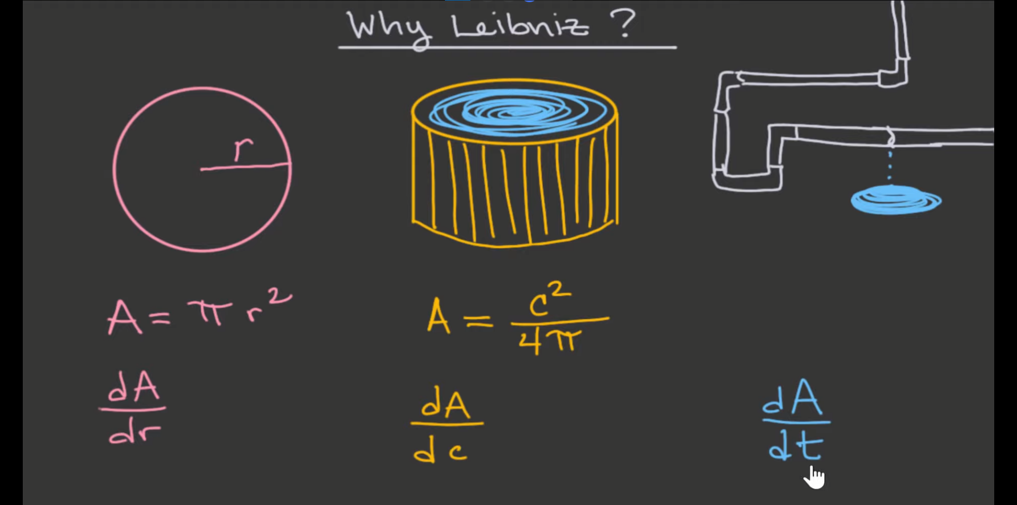

Newton:

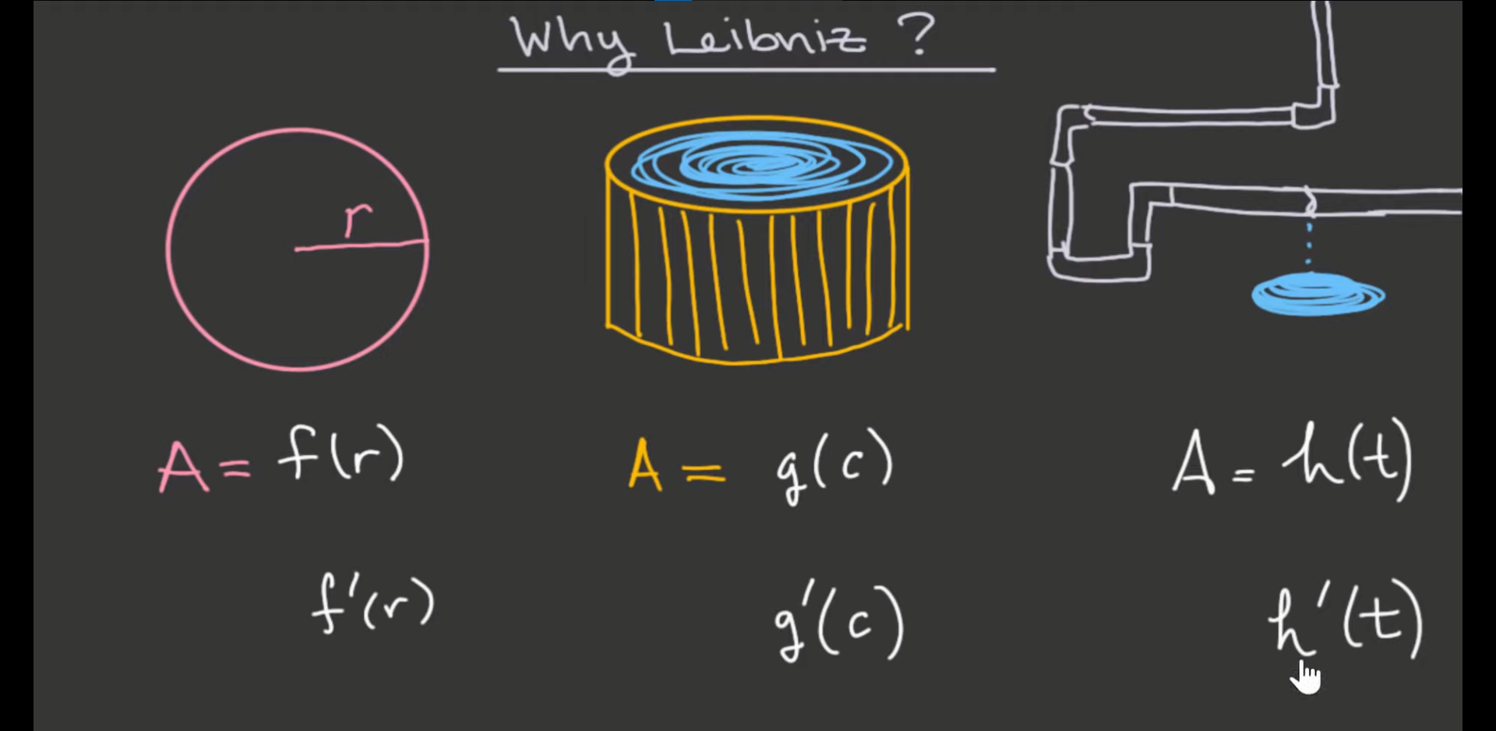

* Less clear of the units
* We don’t know what the functions depict in one look

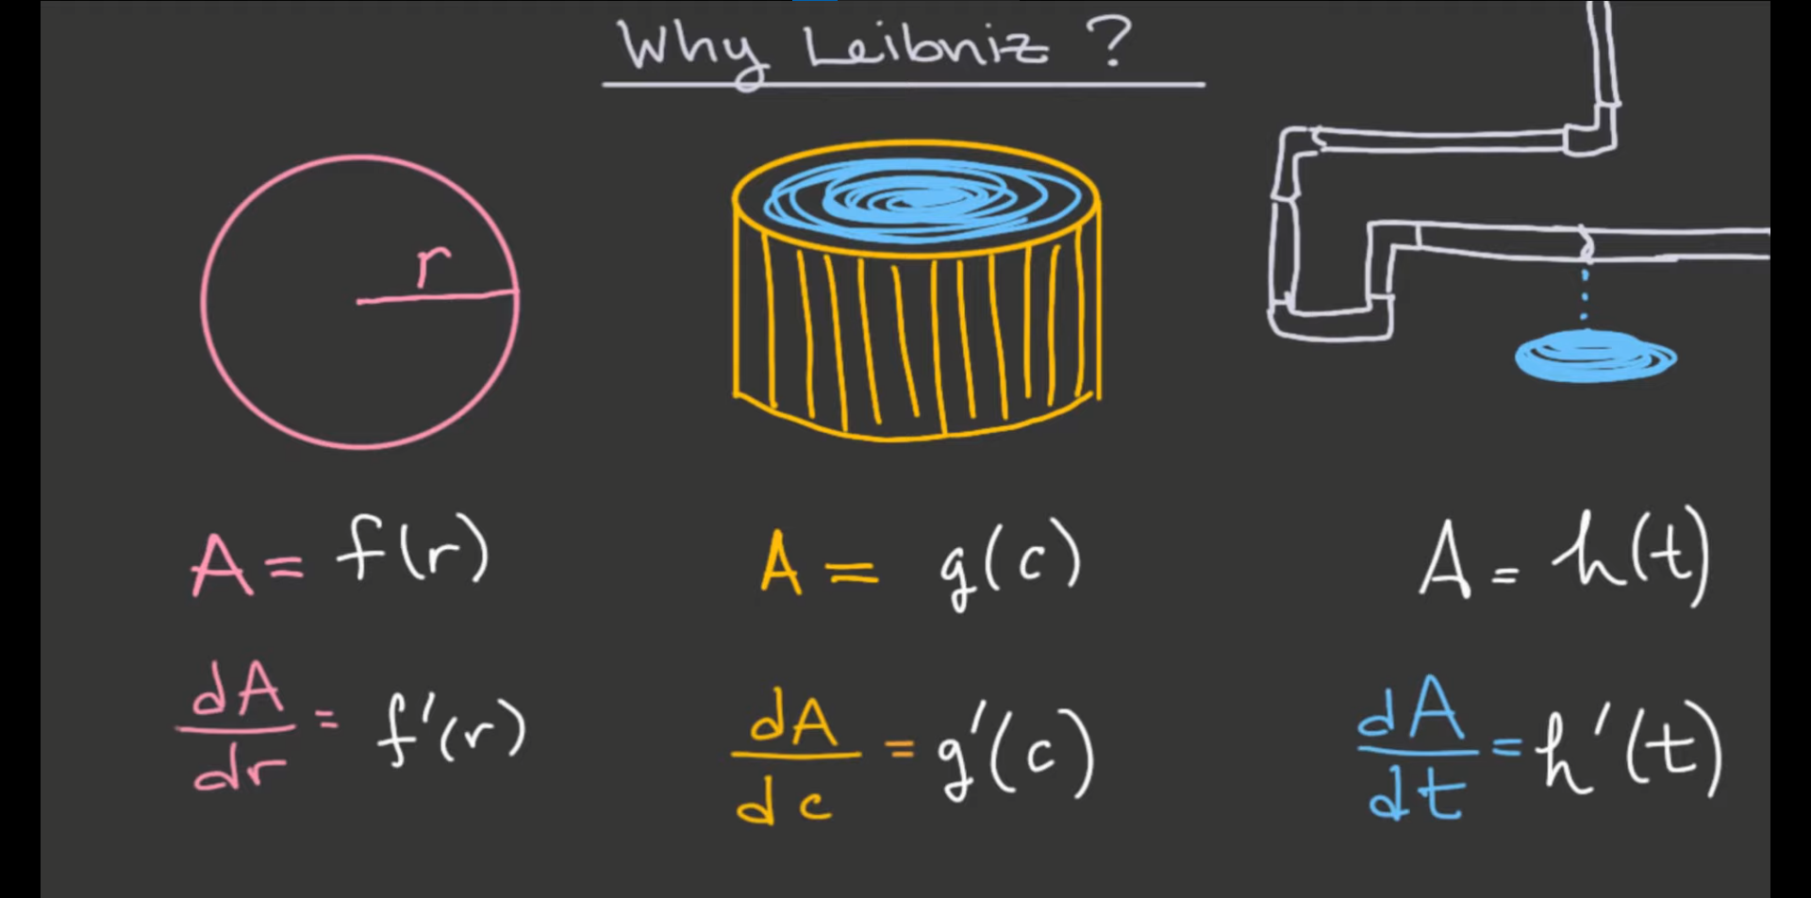

* Leibniz is better esp. real world representations